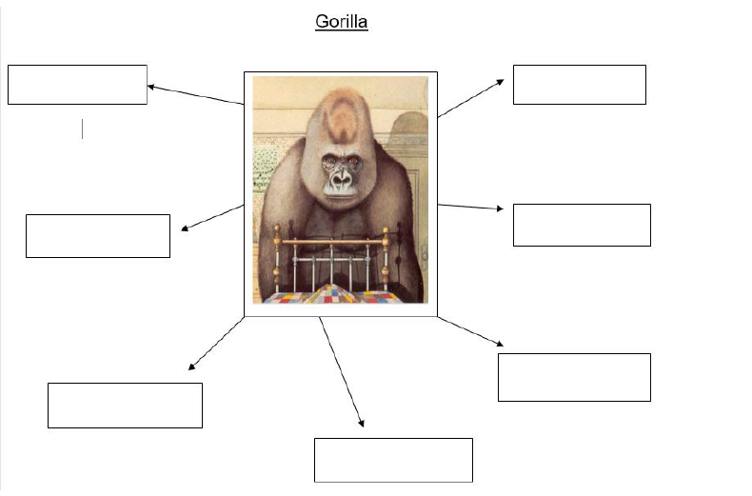
Describe the Gorilla

Draw a picture of the gorilla or use the template opposite, and write some interesting adjectives to describe him.
E.g Gargantuan, mischievous, pristine.

