Sensory exploration of the tree
Use your senses to explore the tree and things that may be growing on or near it.
Touch – What does it feel like?
Smell – What does the bark smell like? What do things around the tree smell of?
Sight - How does the bark look? What words describe this? What size and shape is the tree? What size and shape are the leaves? Does the tree have blossom on it? Is there any fruit on the tree, such as acorns or conkers? What is living on the tree?
Sound – What can you hear when near the tree? What can you hear coming from the tree?

Tree identification
Get an A-Z guide of British trees by downloading the free tree ID app for Android and iOS at

https://www.woodlandtrust.org.uk/trees-woods-and-wildlife/british-trees/how-to-identify-trees/?
Or use the attached sheets to identify leaves, twigs, fruit and blossom.
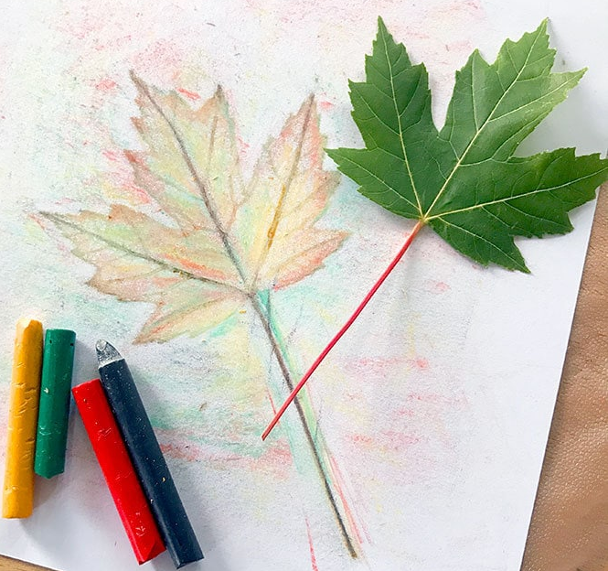
Collect and sketch different leaves
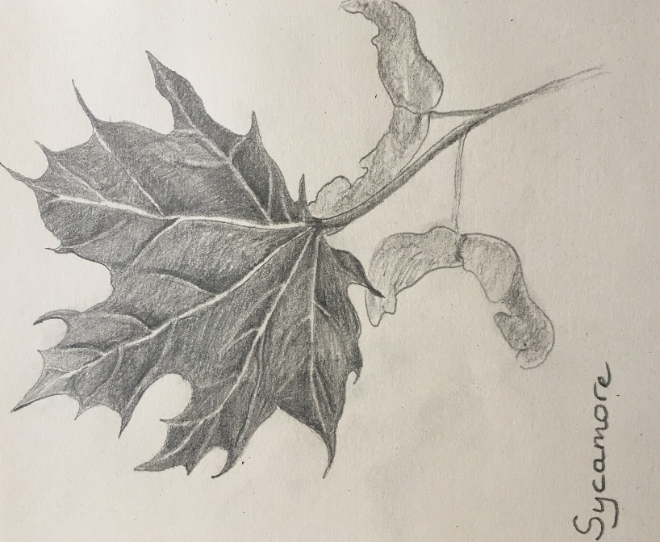
Draw each leaf by carefully looking at its shape. Label it to help you to remember the different tree names.
Remember – draw what you see and not what you think you see!
Press your leaves under a stack of heavy books, and create a study page by putting the pressed leaf against its tree name.
Why not make leaf rubbings, if you struggle to draw the leaf? It is so much fun!!

Make bark rubbings
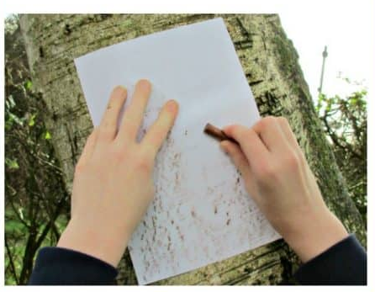
Use a wax crayon or chalk on its side and rub over a piece of paper. Compare the textures and patterns of the bark on different trees.
Talk about: - ‘How are they different?’
‘How are they similar?’
‘Does a tree's age affect how its bark appears on paper?’
‘Did you get different patterns and textures from the same tree, or did the pattern remain the same?’

