LIVING THINGS: CHALLENGE 3

Cut out the animals and decide where each one lives.
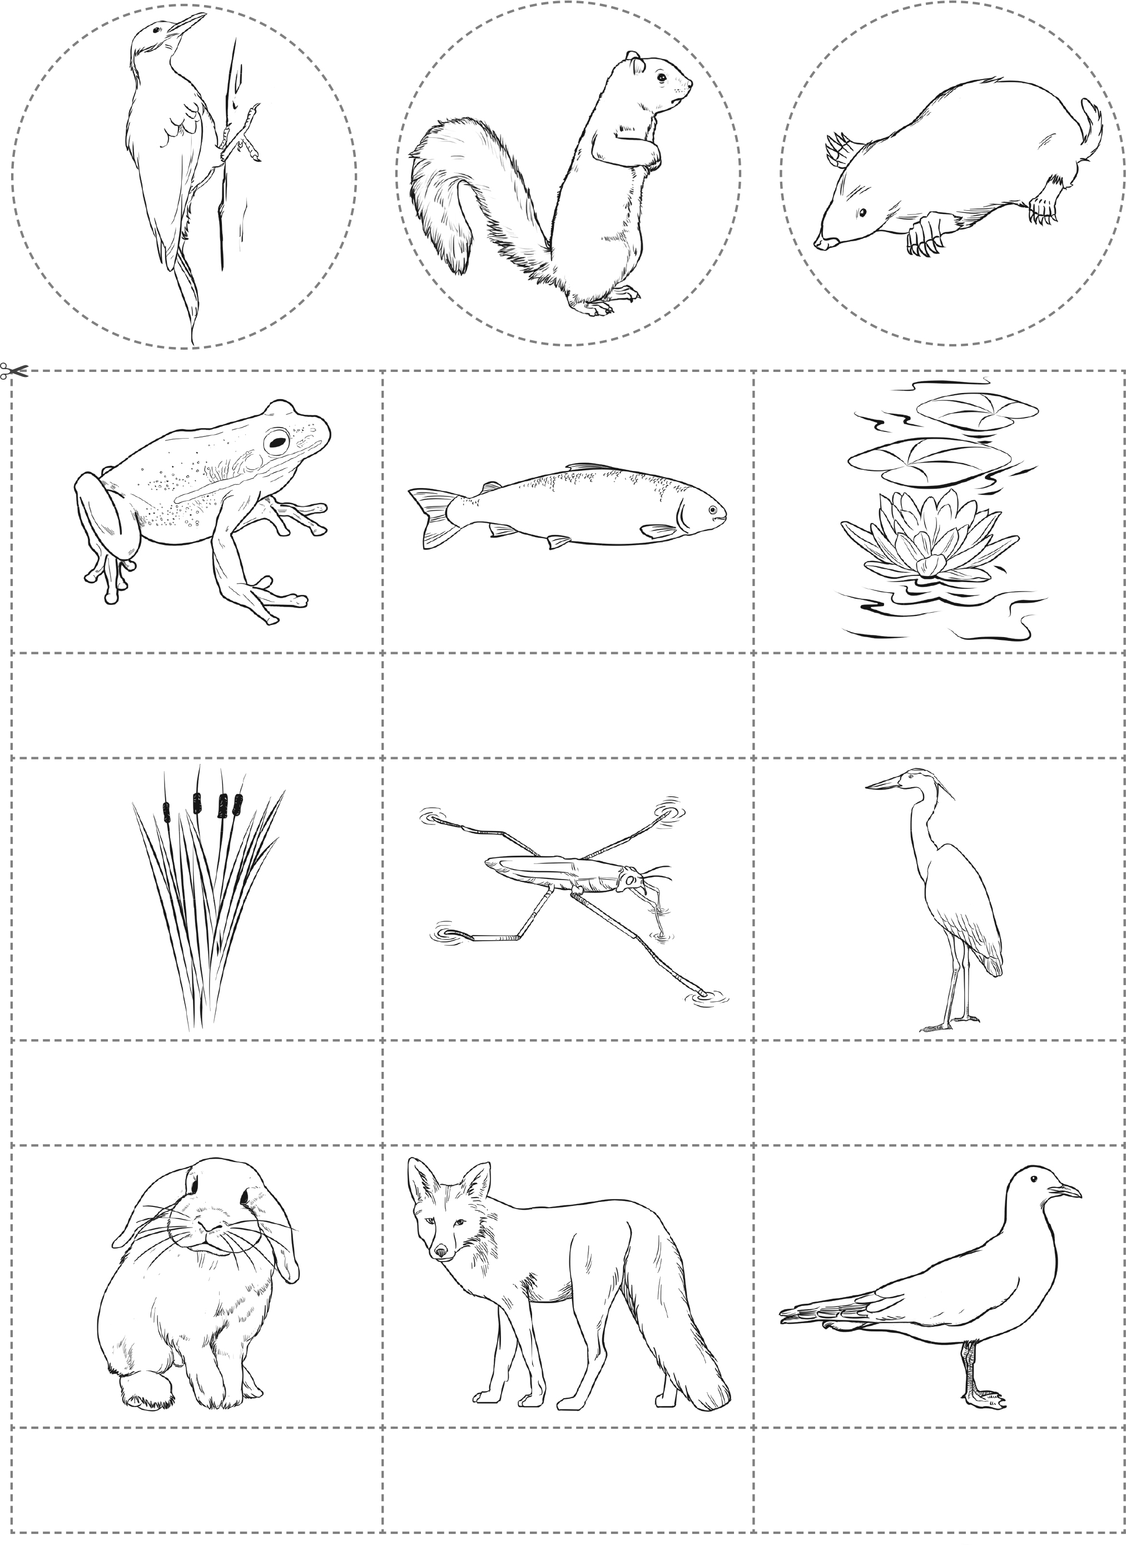
Fox
Rabbit
Seagull
Pond skater
Reeds
Heron
Water lily
Fish
Frog
Rabbit
Pond skater
Reeds
Fish
Frog
Fox

LIVING THINGS: CHALLENGE 3

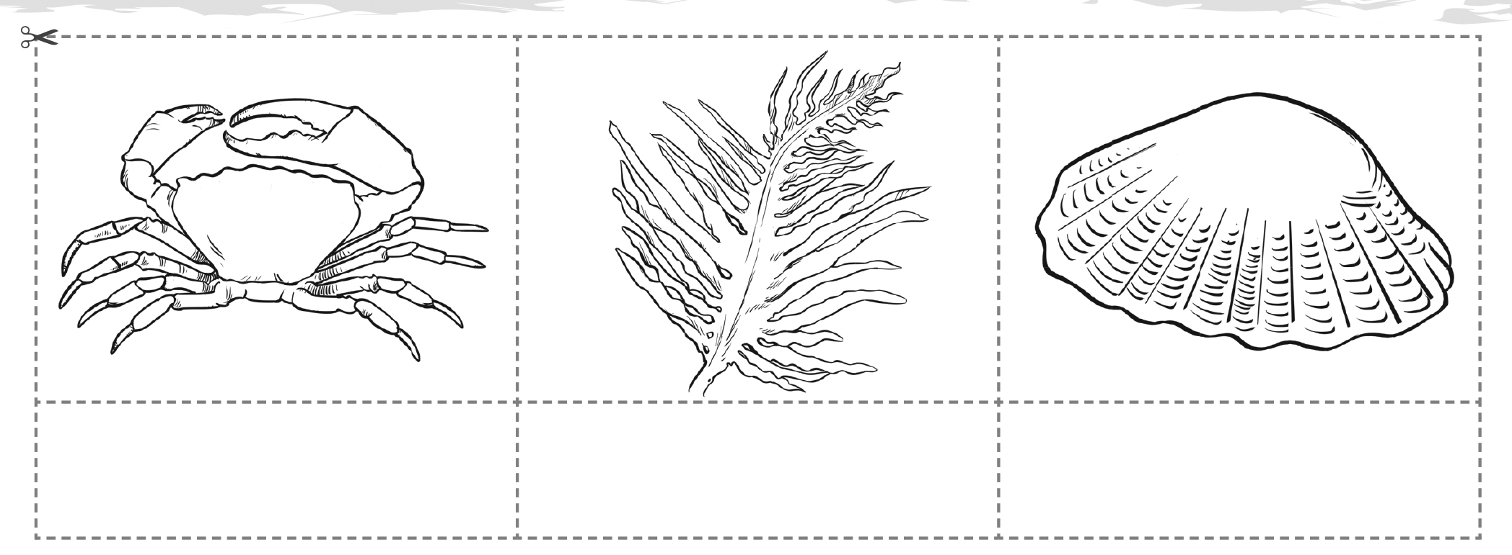
Crab
Limpets
Seaweed

