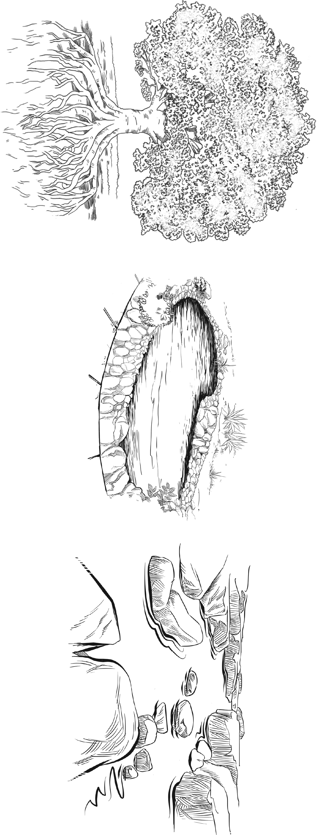
www.collins.co.uk © HarperCollinsPublishers Limited 2014

MODULE 1, LESSON 3, RESOURCE SHEET 5
HABITATS: CHALLENGE 3
Enlarge to A3.

