LIVING THINGS: CHALLENGE 2

Cut out the animals and decide where each one lives.
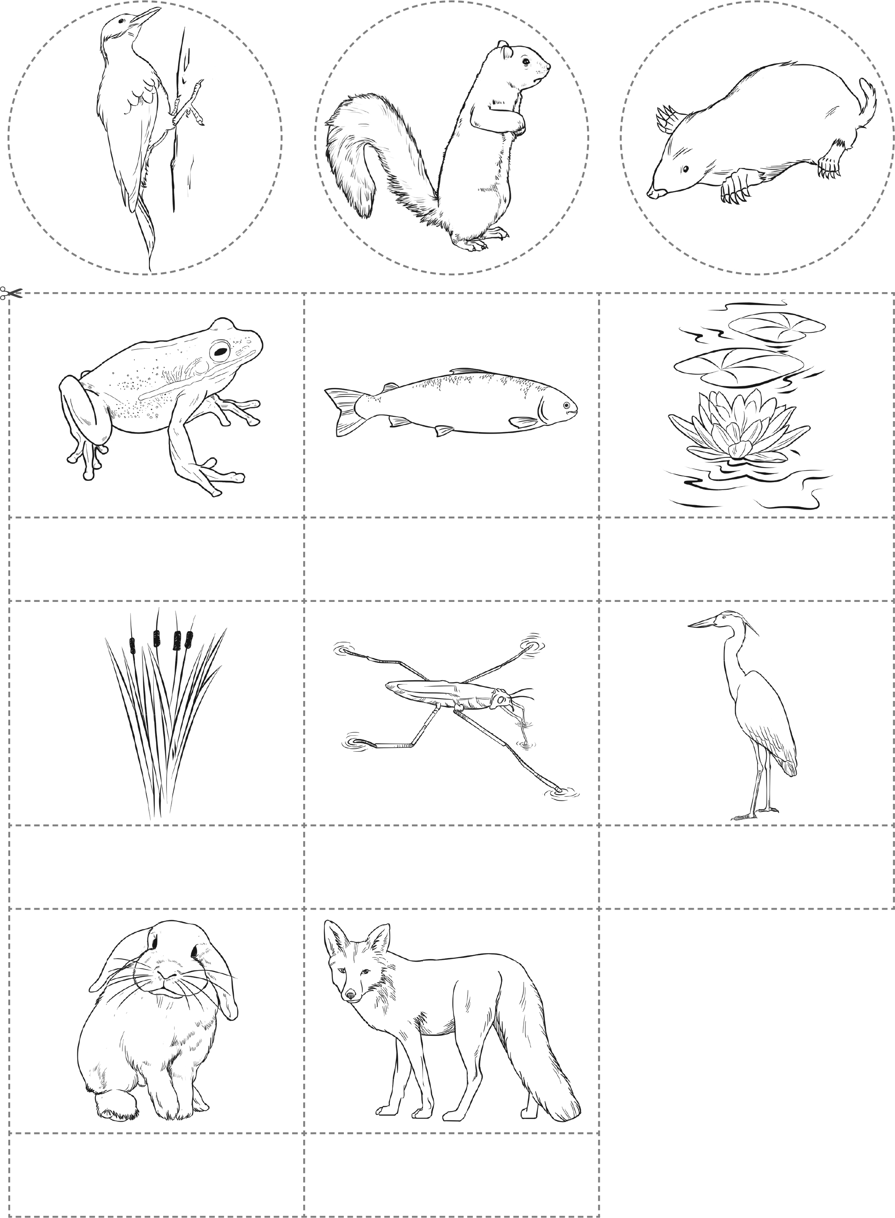
Rabbit
Pond skater
Reeds
Fish
Frog
Heron
Water lily
Fox

