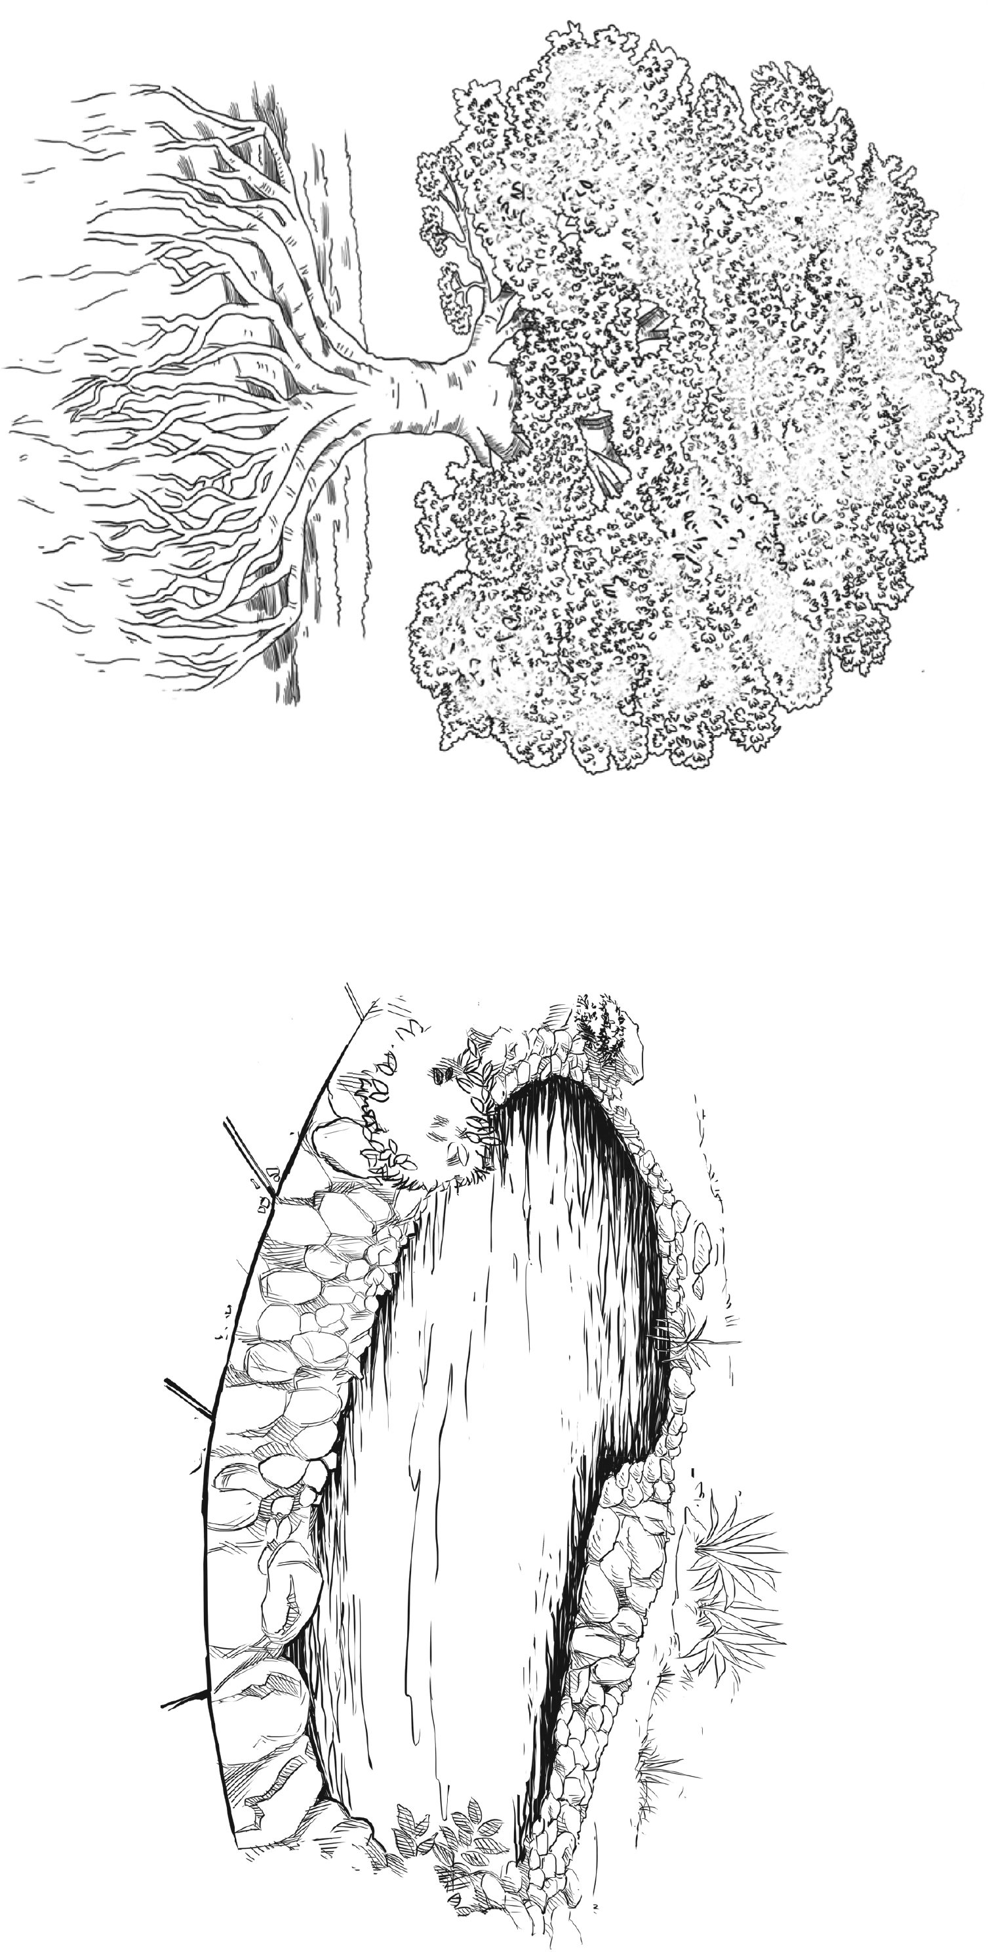
www.collins.co.uk © HarperCollinsPublishers Limited 2014

MODULE 1, LESSON 3, RESOURCE SHEET 3
HABITATS: CHALLENGE 2
Enlarge this page to A3.

