WHO LIVES IN THE OAK TREE?

Cut out the living things and stick them in the correct place on the picture of the
oak tree.

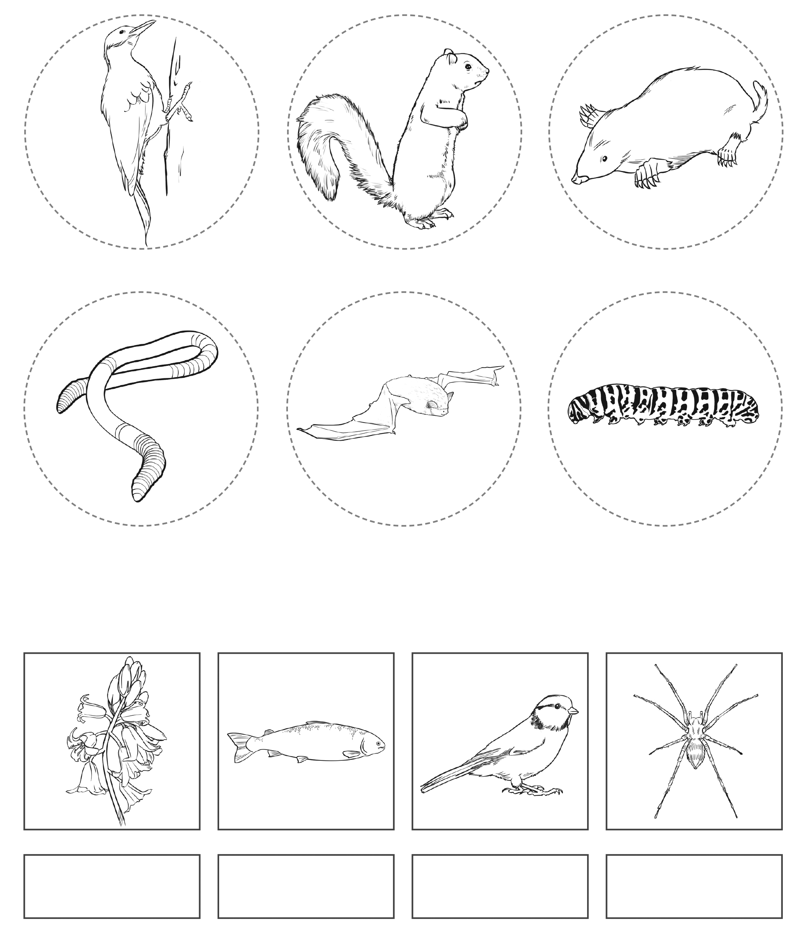
Spider
Bluetit
Fish
Bluebells

