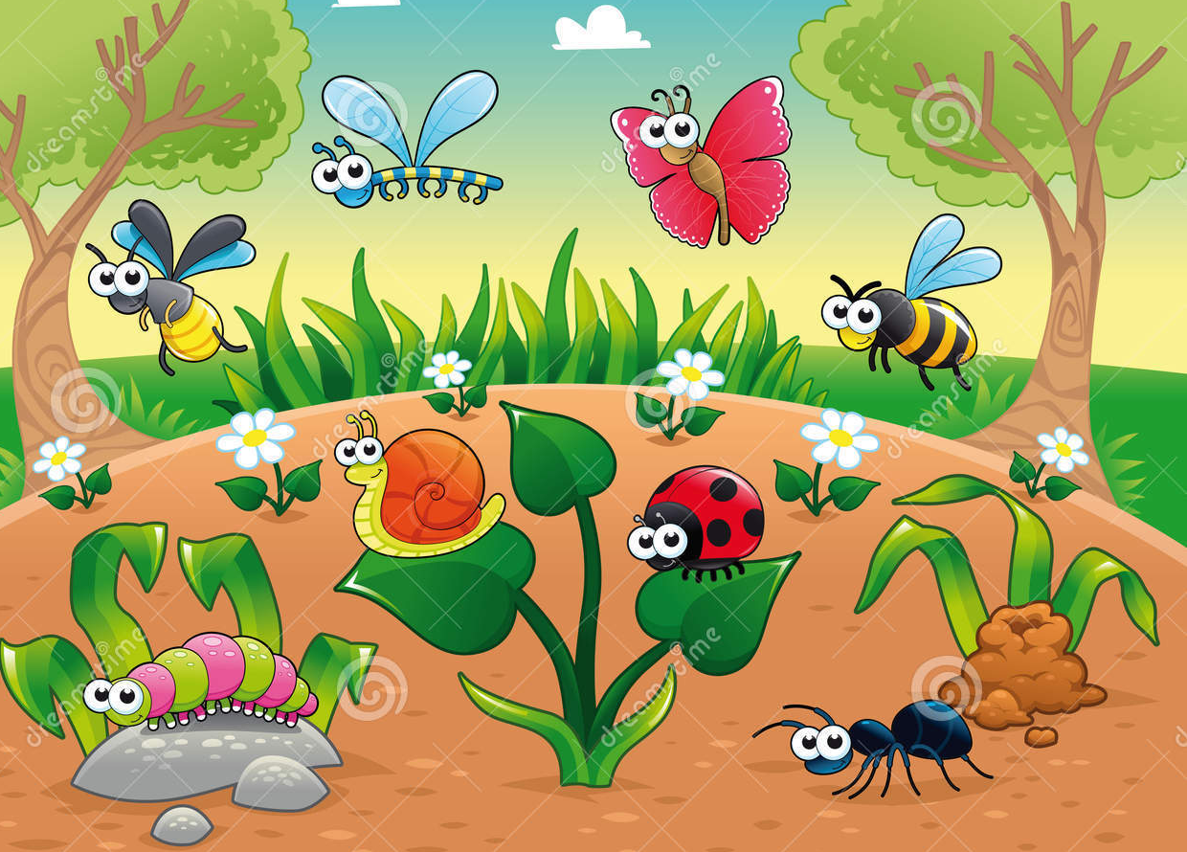
Look at and discuss what you can see in the picture. Use your known sounds to write labels or sentences. Remember to try and use ‘and’ to extend your ideas.

________________________________________________________________________________________________________________________________________________________________________________________________________________________________________________________________________________________________________________________________________________________________________________________________________________________________________________________________________________________________________________________________________________________________________________________________________________________________________________________________________________________________________________________________________________________________________________________________________________________________________________________________

