Monday | Tuesday | Wednesday | Thursday | Friday
Adding numbers that make 10.  (Numberbonds to 10)  What two numbers make 10?  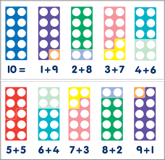  Matching number to quantity. (one to one correspondence)  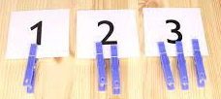  Show me. | Identifying coins.  What coin is it 1p, 2p, 5p, 10p?  How many 1p coins make 2p, 5p, 10p?  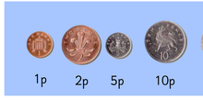  What is this coin?  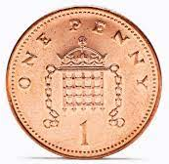 | Counting on from a given number.  Counting on. What number comes after __?  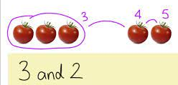  Adding one more.  What is one more than __?  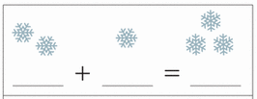 | Subtraction  Taking one away, one less.  What is one less than __?  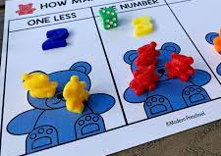 | Shapes 2D  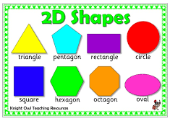  What 2D shapes can I find around the house or in the garden?  Shapes 3D  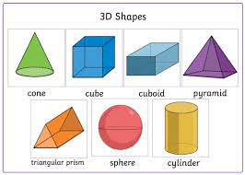  What 3D shapes can I find around the house or in the garden?

