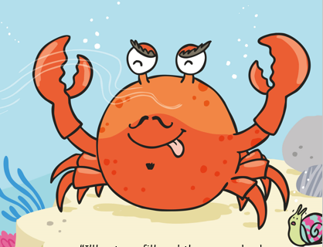

If your friend had someone who was being nasty to them what instructions might you give them?

First_____________________________________________

Next______________________________________________

After that _________________________________________

Finally ___________________________________________

