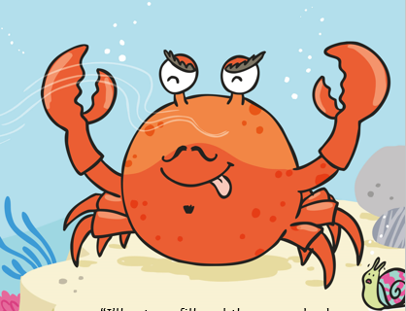

If you had someone who was being nasty to you what instructions might you give them?

