Flatworms

Flatworm Facts 1: Muscular Skeletal
You should know that flatworm has no skeleton at all. It has only cilia. It is the tiny bristles. The function is to help to move and also to become 2 layers of muscles under the skin. There are also 3 cell layers which are called mesoderm, ectoderm, and also endoderm.

Flatworm Facts 2: digestive system
This animal has a unique digestive system. It has the combination of digestive system. People consider this as disgusting because both the food taking and also getting rid of wastes is within the same opening of the flatworm.
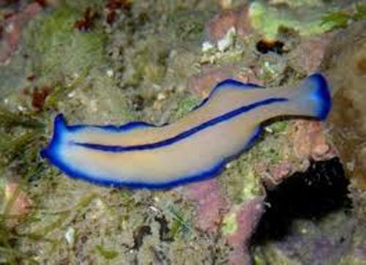
Flatworm Facts

Flatworm Facts 3: Nervous System
The flatworm has simple nervous system. It has 2 nerve cords. In fact, it has simple brain which is called ganglia. It is simple bundle of the nerves. In fact, it has 2 eyespots which can help it to sense the light around.

Flatworm Facts 4: circulation
Next fact is about the circulation. A flatworm has the gastrovascular cavity having one opening. It can eat any tiny worms, microscopic matter, and even any insects.
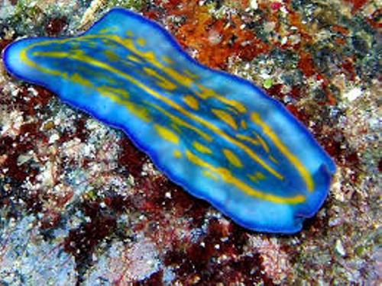
Flatworm Image

Flatworm Facts 5: Respiratory System
Like any other animals, a flatworm takes in oxygen. Although it uses oxygen to breathe, you may recognize that flatworm has no formal system of respiratory.

Flatworm Facts 6: reproduction
In the aspect of reproduction, a flatworm may conduct method such as splitting in two. Once they split up, the new flatworm may occur.
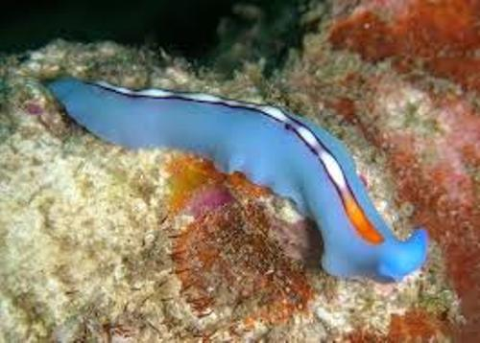
Flatworm in Blue

Flatworm Facts 7: Appearance
You need also to understand about the appearance of this animal. Any flatworm has bilateral symmetry shape. If it is related to appearance, the flatworm can be microscopic or also have long and very thin shape.

Flatworm Facts 8: the diet
Unique fact is that flatworm can be scavengers, herbivores, and also carnivores. They mostly eat protozoan, bacteria, and even small invertebrates.
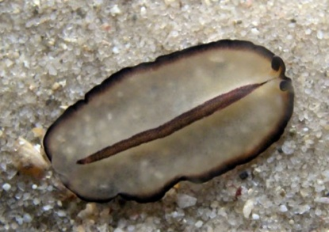
Flatworm Pic

Flatworm Facts 9: The Habitat
Mostly any freshwater flatworms live in lakes, streams, ponds, and also puddles. Usually, flatworm lives below the plants, rocks, and also debris. The reason is to avoid sunlight.

Flatworm Facts 10: the training
Good quality scientist can train flatworm to perform small task. The simple task is such as to find water within the maze.


