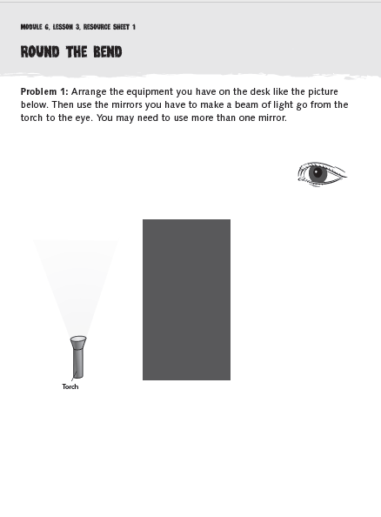
This week in science we are using
what we have learned about how
we see, how light travels and
reflections to carry out some practical
work to investigate how we can bend light.

Use the activity sheets to help you carry
out the investigations at home or, if you
haven’t got the required equipment, research
how periscopes work, where they are used
and draw a diagram of one.

Have fun!!


