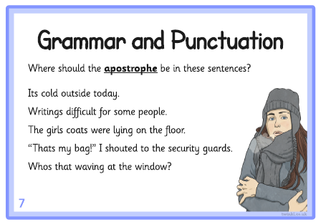

Extension: Now, for each sentence, explain why you have put the apostrophe in that position. (Hint: Think about the two ‘jobs’ of an apostrophe)

