Maths
To practise and use our 6 times table facts
Warm-Up Challenge: Mrs Dougill challenged herself to write out the 6x table as fast as possible without making any mistakes! She managed to do it in 41.5seconds! Can you beat her??? Have a go! Check your answers carefully, if you made any mistakes do it again until you get them right, challenge yourself to get faster and faster until you know your 6x table really well!

Exercise 1: Colour in all of the boxes that are answers in the 6x table
24 | 22 | 18 | 60 | 30
60 | 36 | 48 | 55 | 72
1 | 5 | 37 | 6 | 49
54 | 65 | 48 | 23 | 6
44 | 9 | 24 | 12 | 66

Exercise 2: Complete the circles by multiplying the number in the centre by the middle ring to get the numbers in the outer ring.
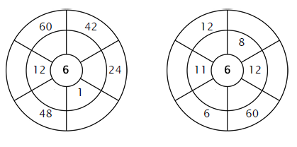

Exercise 3: Fill in the correct product
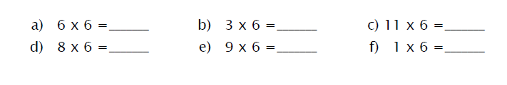
Exercise 4: Draw a line connecting the multiplication expression with the correct product.
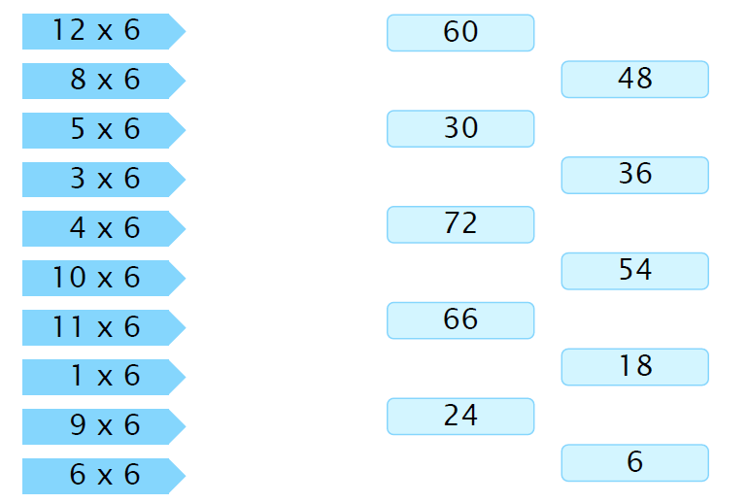
Exercise 5: Fill in the missing number.
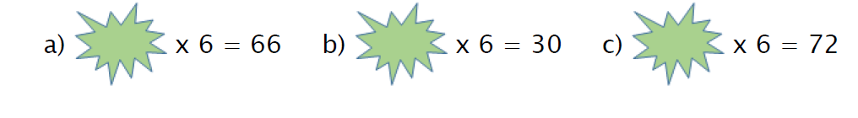
Exercise 6:
If there were 25 children in the class and they each read 6 books this term, how many books will be read in total? Explain how you worked your answer out.

Extension 1: Write down as many related number facts as you can from the triangle below:
48
6
8

Extension 2: Write three word problems which use the 6 x table. (Try to make them challenging). Then write the solutions to your own problems.

