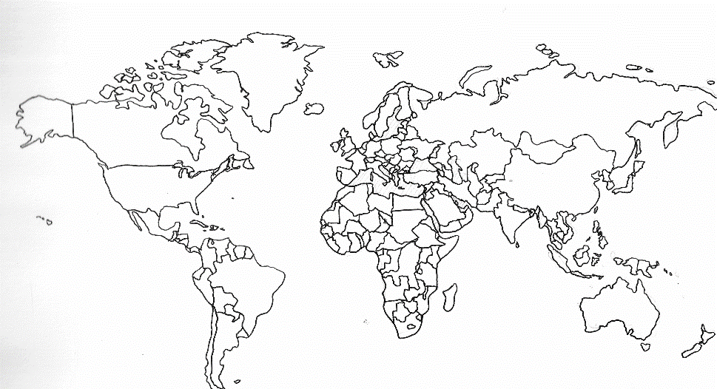
- Colour in the United Kingdom and Mexico in DIFFERENT colours (show the colour in the box)
- Draw over the outline of Mexico
- Label where I would find:
Cities such as: Mexico City, Monterrey, Chihuahua, Cancun and Tijuana
Any airports, tourist resorts, mountain ranges or bodies of water.

United Kingdom

Mexico



