To know some variables that contribute to the extinction of living things
Sort these animals into still in existence today and those which have become extinct.
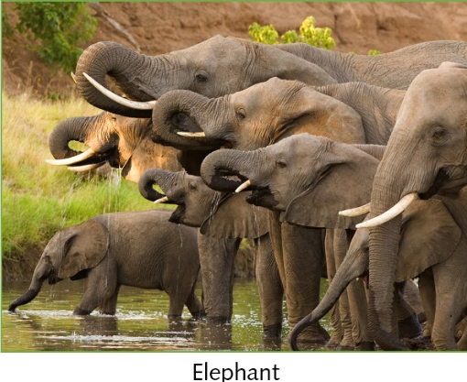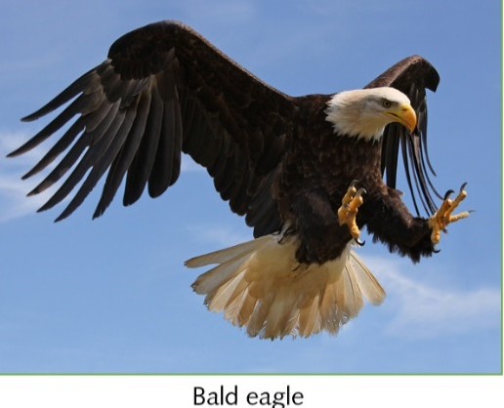
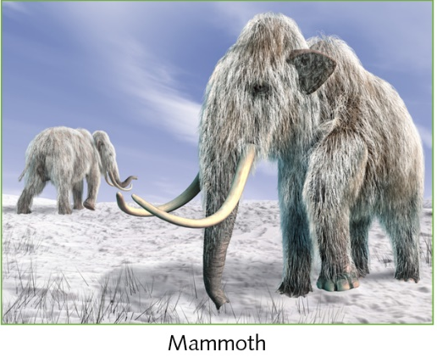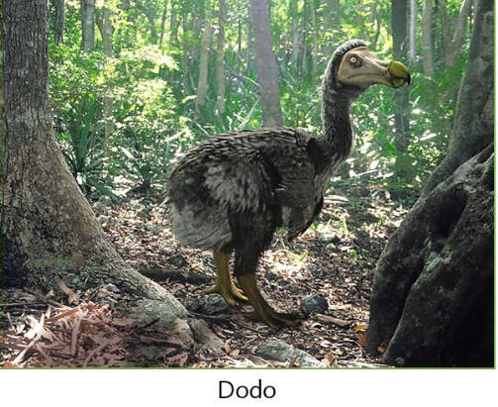

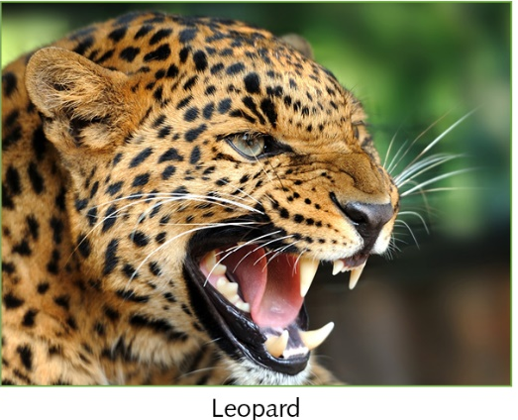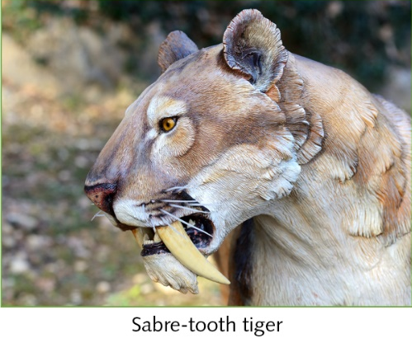
Now choose one of the extinct animals to research and create a poster about.
What was their habitat like?
How was it adapted to its environment?
What did it eat?
Was it a predator/prey/both?
How is it believed to have died out?

